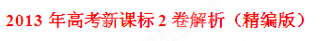
[学科网试卷总评]
本试卷分为英语知识运用、阅读理解和写作三部分。其中，英语知识运用分为单项选择和完形填空；写作部分包括改错和作文。
英语知识运用：第1题考查习惯用语；第2题考查动词短语辨析；第3题考查并列连词；第4题考查定语从句；第5题考查非谓语动词；第6题考查情态动词；第7题考查时态；第8题考查近义词辨析；第9题考查冠词和比较级；第10题考查强调句型；第11题考查介词辨析；第12题考查倒装句型；第13题考查冠词；第14题考查不定代词；第15题考查交际引语。
十五道单项选择题都是对基础知识的考查，难度不大，只要掌握有关的基本语法知识，正确回答是不难的。完形填空主要是对名词、形容词、动词和动词短语的考查，选项没有设置太难的生词，审清题目，联系前后文不难做出判断。
阅读理解：阅读理解有5篇，前4篇是常规题目，题目的设置主要集中在对文章细节的把握上，题目不是太难，每道题目都能在文章中找到依据；例如第36题，依据是文章第一句话；第37题在第二段的最后一句；第40题在第一段的最后一句；第41题在第三段的最后一句；第48题在Gift No.1的第一句；其中有两道猜测词义题（38题，41题），学生联系句子和段落大意不难选出正确的选项。最后一篇重在考查学生总结段意和前后联系的能力，第51题需要联系文章标题Public Speaking Training, Get a coach和51后依据中的so来判断，E项提到了public speaking。
写作：短文改错题着重对语法知识的考查。第1处的I’m reading是定语从句，of多余，这个错误比较难判断，需要有扎实的语法，特别是定语从句的知识；第2处主要考查非谓语动词，动词原形不能作主语，但是动名词和不定式可以作主语，动名词作主语时，谓语用单数，因此把Have改为Having，此处不难改正；第3处考查非限制性定语从句，学生容易忽视句中的逗号，非限制性定语从句不能用that引导；第4处考查时态，应该用过去时，比较容易改正；第5处考查冠词，特指一天用the；第6处考查词形转换，interesting是形容词，不能修饰整个句子，应该用副词，这一空容易被学生忽略；第7处考查固定搭配，have a connection with...与......有联系；第8处考查被动语态，被动语态的结构是be+过去分词，drink的过去分词是drunk；第9处考查名词，cup可数，这里应该用复数；第10处考查词形转换，make for后加名词，grow的名词是growth。
作文是书信格式，考生比较容易下笔，另外，给出了要点，只要围绕要点进行展开就可以了。写作时要注意书信的格式。
试卷总体偏易，比较适合教育不发达地区使用，符合当地教学的实际情况。
第一部分 英语知识运用(共两节，满分45分)
- 单项填空(共15小题；每小题1分，满分15分)
从A、B、C、D四个选项中选出可以填入空白处的最佳选项，并在答题卡上将该选项涂黑。
例: It is generally considered unwise to give a child he or she wants.
A. however B. whatever C. whichever D. whenever
答案是B。
1．--I'm sorry I made a mistake!
-- Nobody is perfect.
- Take your time B. You're right C.Whatever you say D. Take it easy
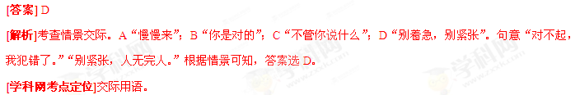2. Would you like to with us to the film tonight?
A. come along B. come off C. come across D. come through
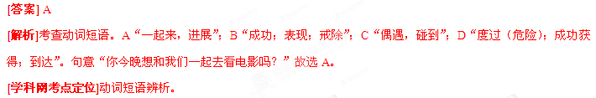3. I was glad to meet Jenny again, I didn't want to spend all day with her.
A. but B. and C.so D.or
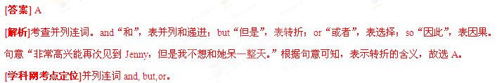4. When I arrived, Bryan took me to see the house_ I would be staying.
A. what B. when C. where D. Which
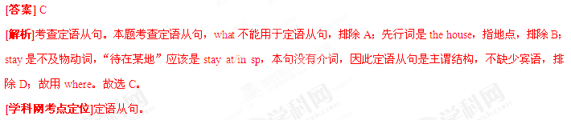5.I got to the office earlier that day, the 7:30 train from Paddington.
A.caught B. to have caught C. to catch D. having caught
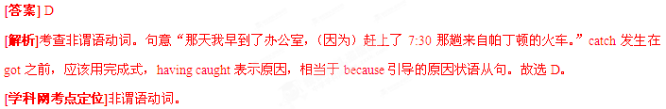6. Since nobody gave him any help, he have done the research on his own.
A. can B. must C. would D. Need
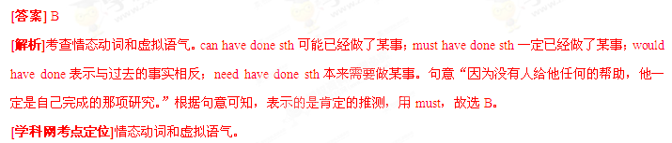7. We very early so we packed the night before.
A. leave B. had left C. were leaving D.have left
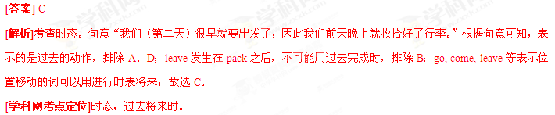8. The watch was very good, and he 20 percent down for it.
A. paid B. cost C. bought D. Spent
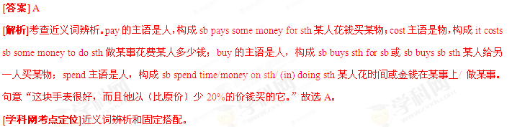9. It may not be a great suggestion. But before _______ is put forward, we’ll make do with it.
A. a good one B. a better one C. the best one D. a best one
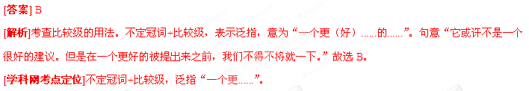10. It was only after he had read the papers Mr. Gross realized the task before him was extremely difficult to complete.
Awhen B. that C. which D. What
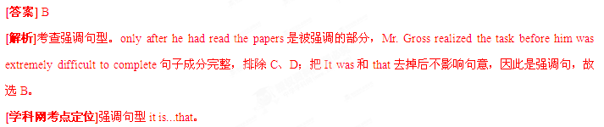11. A serious study of physics is impossible some knowledge of mathematics.
- against B. before C. beyond D. without
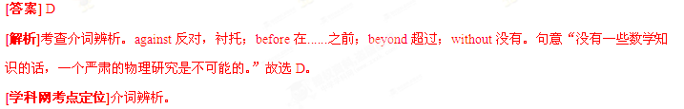12. Only by increasing the number of doctors by 50 percent properly in this hospital.
A. can be the patients B. can the patients be treated
C. the patients can be treated D.treated can be the patients
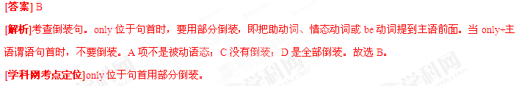13. Four and half hours of discussion took us up to midnight,and break for cheese,chocolate and tea with sugar.
A.a;a B. the; the C.不填；the D.a;不填
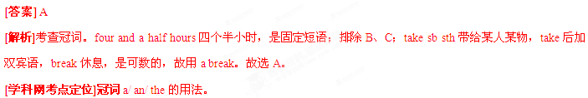14. It's an either-or situation - we can buy a new car this year or we can go on holiday but we can’t do .
A.others B. either C.another D. Both
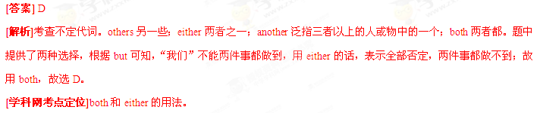15. -Are you sure you won't come for a drink with us?
- , if you insist.
- Not at all B. It depends C. All right then D.I don't care
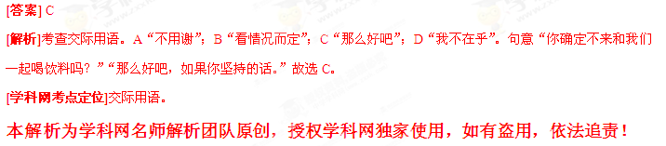第二节 完形填空（共20小题；每小题1.5分，满分30分）
阅读下面短文，从短文后面各题锁哥的四个选项(A、 B、C 和 D)中选出可以填入空白处的最佳选项，并在答题卡上将该项涂黑。
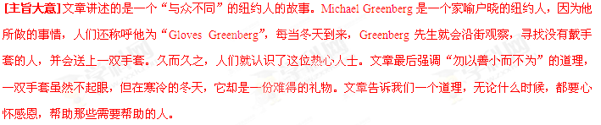 Michael Greenberg is a very popular New Yorker. He is not famous in sports or the arts, But people in the streets 16 him, especially those who are 17 .
For those people, he is "Gloves" Greenberg. How did he get that 18 ?
He looks like any otner businessman, wearing a suit and carrying a briefcase (公文箱). But he's 19 _. His briefcase always has some gloves。
In winter,Mr.Greenberg does not 20 like other New Yorkers,who look at the sidewalk and 21 the street.He looks around at 22 .He stops when he 23 someone with no gloves.He gives them a pair and then he 24 ,looking for more people with cold 25 .
On winter days,Mr.Greenberg 26 gloves.During the rest of the year,he 27 gloves.People who have heard about him 28 him gloves,and he has many in his apartment.
Mr. Greenberg 29 doing this 21 years ago. Now, many poor New Yorkers know him and 30 his behavior. But people who don't know him are sometimes 31 him. They don't realize that he just wants to make them 32 .
It runs in the 33 .Michael's father always helped the poor as he believed it made everyone happier. Michael Greenberg feels the 34 .A pair of gloves may be a 35 thing,but it can make a big difference in winter.
- A..know about B. learn from C. cheer for D. look after
17. A. old B. busy C. kind D.poor
18. A. iob B. name C. chance D. message
19.A.calm B.different C.crazy D.curious
20.A.act B.sound C.feel D.dress
21.A.cross over B. drive along C. hurry down D. keep off
22. A. cars B. people C. street numbers D. traffic lights
23.A.helps B .chooses C.greets D.sees
24.A.holds up B.hangs out C.moves on D.turns around
25.A.hands B. ears C.faces D. eyes
26. A. searches for B. stores up C.gives away D. puts on
27. A. borrows B. sells C.returns D. buys
28. A. call B. send C. lend D. show
29. A. delayed B. remembered C. began D. enjoyed
30.A.understand B.dislike C.study D.excuse
31.A.sorry for B.satisfied with C.proud of D.surprised by
32.A.smart B.rich C.special D.happy
33.A.city B.family C.neighborhood D.company
34.A.honor B.pain C.same D.cold
35.A.small B.useful C.delightful Dcomforting
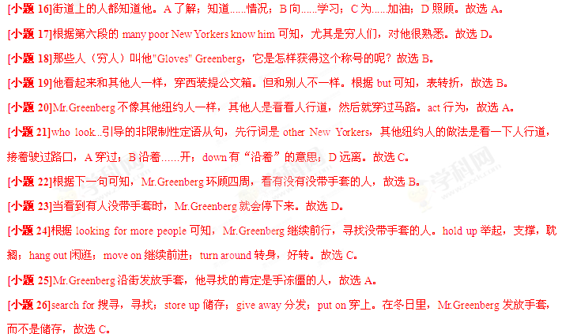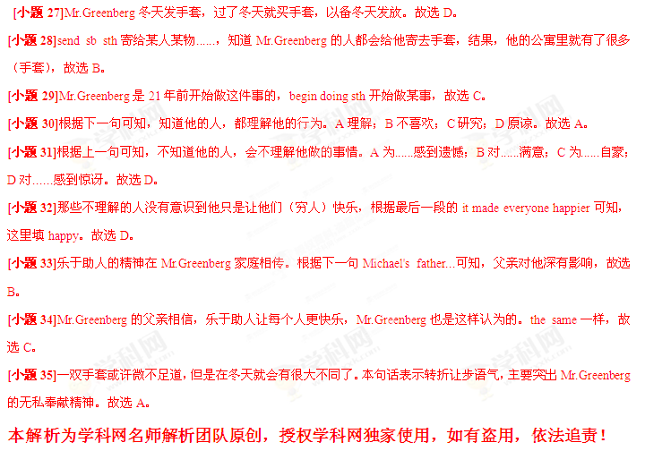第二部分阅读理解(共两节，满分40分)
第一节 (共15小题；每小题2分，满分30分)
阅读下列短文，从每题所给的四个选项(A、 B、 C和D)中，选出最佳选项，并在答题卡上将该项涂黑。
[主旨大意]文章讲述了医生这个行业存在的通病，作者以自己为例，讲述了自己通过当飞行员，而学会了一种管理方式（CRM），并运用到平时的医护工作中去。在工作中，领导要鼓励员工提出意见或建议，以避免出现错误或提高工作效率。
A
Doctor are known to be terrible pilots. They don't listen because they already know it all. I was lucky: I became a pilot in 1970, almost ten years before I graduated from medical school. I didn't realize then, but becoming a pilot makes me a better surgeon. I loved flying. As I flew bigger, faster planes, and in worse weather. I learned about crew resource management (机组资源管理), or CRM, a new idea to make flying safer. It means that crew members should listen and speak up for a good result, regardless of positions.
I first read about CRM in 1980. Not long after that, an attending doctor and I were flying in bad weather. The controller had us turn too late to get our landing ready. The attending doctor was flying; I was safety pilot He was so busy because of the bad turn, he had forgotten to put the landing gear (起落架) down. He was a better pilot - and my boss - so it felt unusual to speak up. But I had to: Our lives were in danger. I put aside my uneasiness and said, "We need to put the landing gear down now!" That was my first real lesson in the power of CRM, and I've used it in the operating room ever since.
CRM requires that the pilot/surgeon encourage others to speak up. It further requires that when opinions are from the opposite, the doctor doesn't overreact, which might prevent fellow doctors from voicing opinions again. So when I'm in the operating room, I ask for ideas and help from others. Sometimes they're not willing to speak up. But I hope that if I continue to encourage them , someday someone will keep me from “landing gear up”.
36.What dose the author say about doctors in general?
A. They like flying by themselves.
B. They are unwilling to take advice.
C. They pretend to be good pilots.
D. They are quick learners of CRM.
37.The author deepened his understanding of the power of CRM when_______.
A. he saved the plane by speaking up
B. he was in charge of a flying task
C. his boss landed the plane too late
D. his boss operated on a patient
38.In the last paragraph”landing gear up” probably means ______.
A.following flying requirements.
B.overreacting to different opinions.
C.listening to what fellow doctors say
D.making a mistake that may cost lives
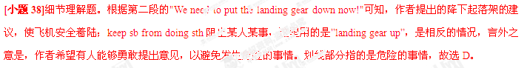39.Which of the following can be the best title for the text?
A.CRM:A New Way to Make Flying Safe
B.Flying Makes Me a Better Doctor
C.The Making of a Good Pilot
D.A Pilot-Tumed Doctor
B
In 1947 a group of famous people from the art world headed by an Austrian conductor decided to hold an intemational festival of music,dance and theatre in Edinburgh. The idea was to reunite Europe after the Second World War.
At the same time, the “Fringe” appeared as a challenge to the official festival.Eight theatre groups turned up uninvited in 1947,in the belief that everyone should have the right to perform,and they did so in a public house disused for years.
Soon,groups of studentsfirstly from Edinburgh University, and later from the universities of Oxford and Cambridge,Durham and Birmingham were making the journey to the Scottish capital each summer to perform theatre by little-known writers of plays in small church halls to the people of Edinburgh.
Today the “Fringe”,once less recognized, has far outgrown the festival with around 1,500 performances of theatre,music and dance on every one of the 21 days it lasts. And yet as early as 1959,with only 19 theatre groups performing,some said it was getting too big.
A paid administrator was first employed only in 1971, and today there are eight administrators working all year round and the number rises to 150 during August itself. In 2004 there were 200 places housing 1,695 shows by over 600 different groups from 50 different countries. More than 1,25 million tickets were sold.
40. Point was the purpose of Edinburgh Festival at he beginning?
A. To bring Europe together again.
B. To honor heroes of World War 11.
C. To introduce young theatre groups.
D. To attract great artists from Europe.
41. Why did some uninvited theatre groups come to Edinburgh in 1947?
A. They owned a public house there.
B. They came to take up a challenge.
C. They thought they were also famous.
D. They wanted to take part in the festival.
42. Who joined the "Fringe" after it appeared?
A.they owned a public house there
B. University students.
C.人rusts from around the world.
D. Performers of music and dance.
43. We may learn from the text that Edinburgh Festival.
A. has become a non-official event
B. has gone beyond an art festival
C. gives shows all year round
D. keeps growing rapidly
C
Given that many people's moods (情绪)are regulated by the chemical action of chocolate, it was probably only a matter of time before somebody made the chocolate shop similar to a drug store of Chinese medicine. Looking like a setting from the film Charlie&the Chocolate Factory, Singapore's Chocolate Research Facility (CRF) has over 100 varieties of chocolates.its founder is Chris Lee who grew up at his parents' corner store with one hand almost always in the jar of sweets.
If the CRF seems to be a smart idea, that's because Lee is not merely a seasoned salesperson but also head of a marketing department that has business relations with big names such as Levi's and Sony. That idea surely results in the imagination at work when it comes to making different flavored(味道)chocolates.
The CRF's produce is "green". made within the country and divided into 10 lines, with the Alcohol Series being the most popular. The Exotic Series一with Sichuan pepper, red bean (豆).cheese and other flavors一also does well and is fun to taste. And for chocolate snobs，who think that they have a better knowledge of chocolate than others, the Connoisseur Series uses cocoa beans from Togo, Cuba, Venezuela , and Ghana, among others.
44. What is good about chocolate?
A. It serves as a suitable gift.
B. It works as an effective medicine.
C. It helps improve the state of mind.
D. It strengthens business relations.
45. Why is Chris Lee able to develop his idea of the CRF?
A. He knows the importance of research.
B. He learns form shops of similar types.
C. He has the support of many big names
D. He has a lot of marketing experience.
46. Which line of the CRF produce sells best?
A. The Connoisseur Series.
B. The Exotic Series.
C. The Alcohol Series.
D. The Sichuan Series.
47. The words "chocolate snobs" in Paragraph 3 probably refer to people who
A. are particular about chocolate
B. know little about cocoa beans
C. look down upon others
D. like to try new flavors
D
[主旨大意]文章介绍了几种在母亲节，可以送给妈妈的、物美价廉的礼物。
Low-Cost Gifts for Mother's Day
Gift No. I
Offer to be your mother's health friend. Promise to be there for any and all doctor's visits
whether a disease or a regular medical check-up. Most mothers always say "no need," another set of eyes and ears is always a good idea at a doctor's visit. The best part ? This one is free.

Gift No. 2
Help your mother organize all of her medical records, which include the test results and medical information. Put them all in one place. Be sure to make a list of all of her medicines and what times she takes them. "Having all this information in one place could end up saving your mother's life," Dr. Marie Savard said.
Gift No. 3
Enough sleep is connected to general health conditions. "Buy your mother cotton sheets and comfortable pillows to encourage better sleep," Savard said. "We know that good sleep is very important to our health."
Gift No. 4
Some gift companies such as Presents for Purpose allow you to pay it forward this Mother's Day by picking gifts in which 10 percent of the price you pay goes to a charity (慈善机构) Gift givers can choose from a wide variety of useful but inexpensive things -many of which are "green" - and then choose a meaningful charity from a list. When your mother gets the gift, she will be told that she has helped the chosen charity.
48. What are you advised to do for your mother at doctor's visits?
A. Take notes.
B. Be with her.
C. Buy medicine.
D. Give her gifts.
49. Where can you find a gift idea to improve your mother’s sleep?
A. In Gift No. 1. B. In Gift No. 2.
C. In Gift No. 3. D. In Gift No. 4.
50. Buying gifts from Presents for Purpose allows mothers to
A. enjoy good sleep B. be well-organized
C. bet extra support D. give others help
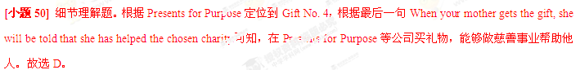第二节（共5小题；每小题2分，满分10分）
根据根据短文内容，从短文后的选项中选出能填入空白处的最佳选项。选项中有两项为多于选项。
Public Speaking Training
·Get a coach
51 ，so get help. Since there are about a billion companies out there all ready to offer you public speaking training and courses, here are some things to look for when deciding the training that's right for you.
·Focus on positives
Any training you do to become more effective at public speaking should always focus on the positive aspects of what you already do well. Nothing can hurt confidence more than being told that you aren't doing well. , so good public speaking training should develop those instead of telling you what you shouldn't do.

If you find a public speaking course that looks as though it's going to give you lots of dos and don'ts, walk away! Your brain is so full of what you're going to be talking about.
54 . As far as we're concerned, there are basically no hard and fast rules about public speaking. Your audience can be your friends.
·You are a special person not a clone
Most importantly, good public speaking training should treat you as a special one, with your own personal habits. 55 . Your training course should help you bring out your
personality, not try to turn you into someone you're not.
A. You aren't like anybody else
B. You already do lots of things well
C. Turn your back on too many rules
D. Check the rules about dos and don'ts
E. Whatever the presentation, public speaking is tough
F .The one thing you don't want is for them to fall asleep
G. So trying to force a whole set of rules into it will just make things worse
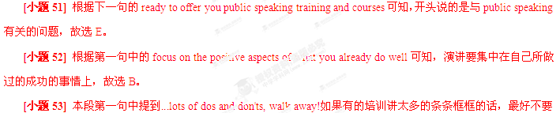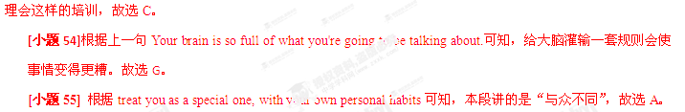2013年普通高等学校招生全国统一考试
英 语
第Ⅱ卷
注意：将答案写在答题卡上。写在本试卷上无效。
第三部分 写作（共两页，满分35分）
第一节 短文改错（共10小题；每小题1分，满分10分）
假定英语课上老师要求同桌之间交换修改作文，请你修改你同桌写的以下作文。文中共有10处语言错误，每句中最多有两处，每处错误仅涉及一个单词的增加、删除或修改。
增加：把缺词处加一个漏符号（∧），并在其下面写出该加的词。
删除：把多余的词用斜线（\）划掉。
修改：在错的词下划一横线，并在该词下面写出修改后的词。
注意：1. 每处错误及其修改均仅限一词；
2. 只允许修改10处，多者（从第11处起）不计分。
The book I’m reading of talks about afternoon tea in Britain. It is said to have started in the early 1800’s. Have tea in the late agternoon provides a bridge between lunch and dinner, that might not be served until 8 o’clock at night. This custom soon becomes another meal of day. Interesting, it had a connection by the British porcelain(瓷器) industry. Tea in China was traditionally drank from cups without handles. When tea got popular in Britain, there was a crying need for good cup with handles to suit British habits. This made for the grow in the porcelain industry.
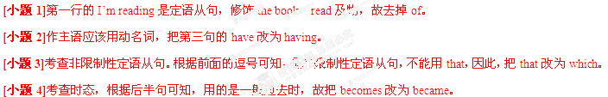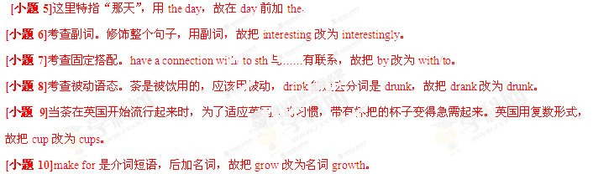第二节 书面表达（满分25分）
假定你是李华，自制一些中国结（Chinese knot）。给开网店的美国朋友Tom写封信，请他代卖，要点包括：
1.外观（尺寸、颜色、材料）
2.象征意义
3.价格
注意：1.词数100左右；
2.可以适当增加细节，以使行文连贯；
3.开头语已为你写好。
